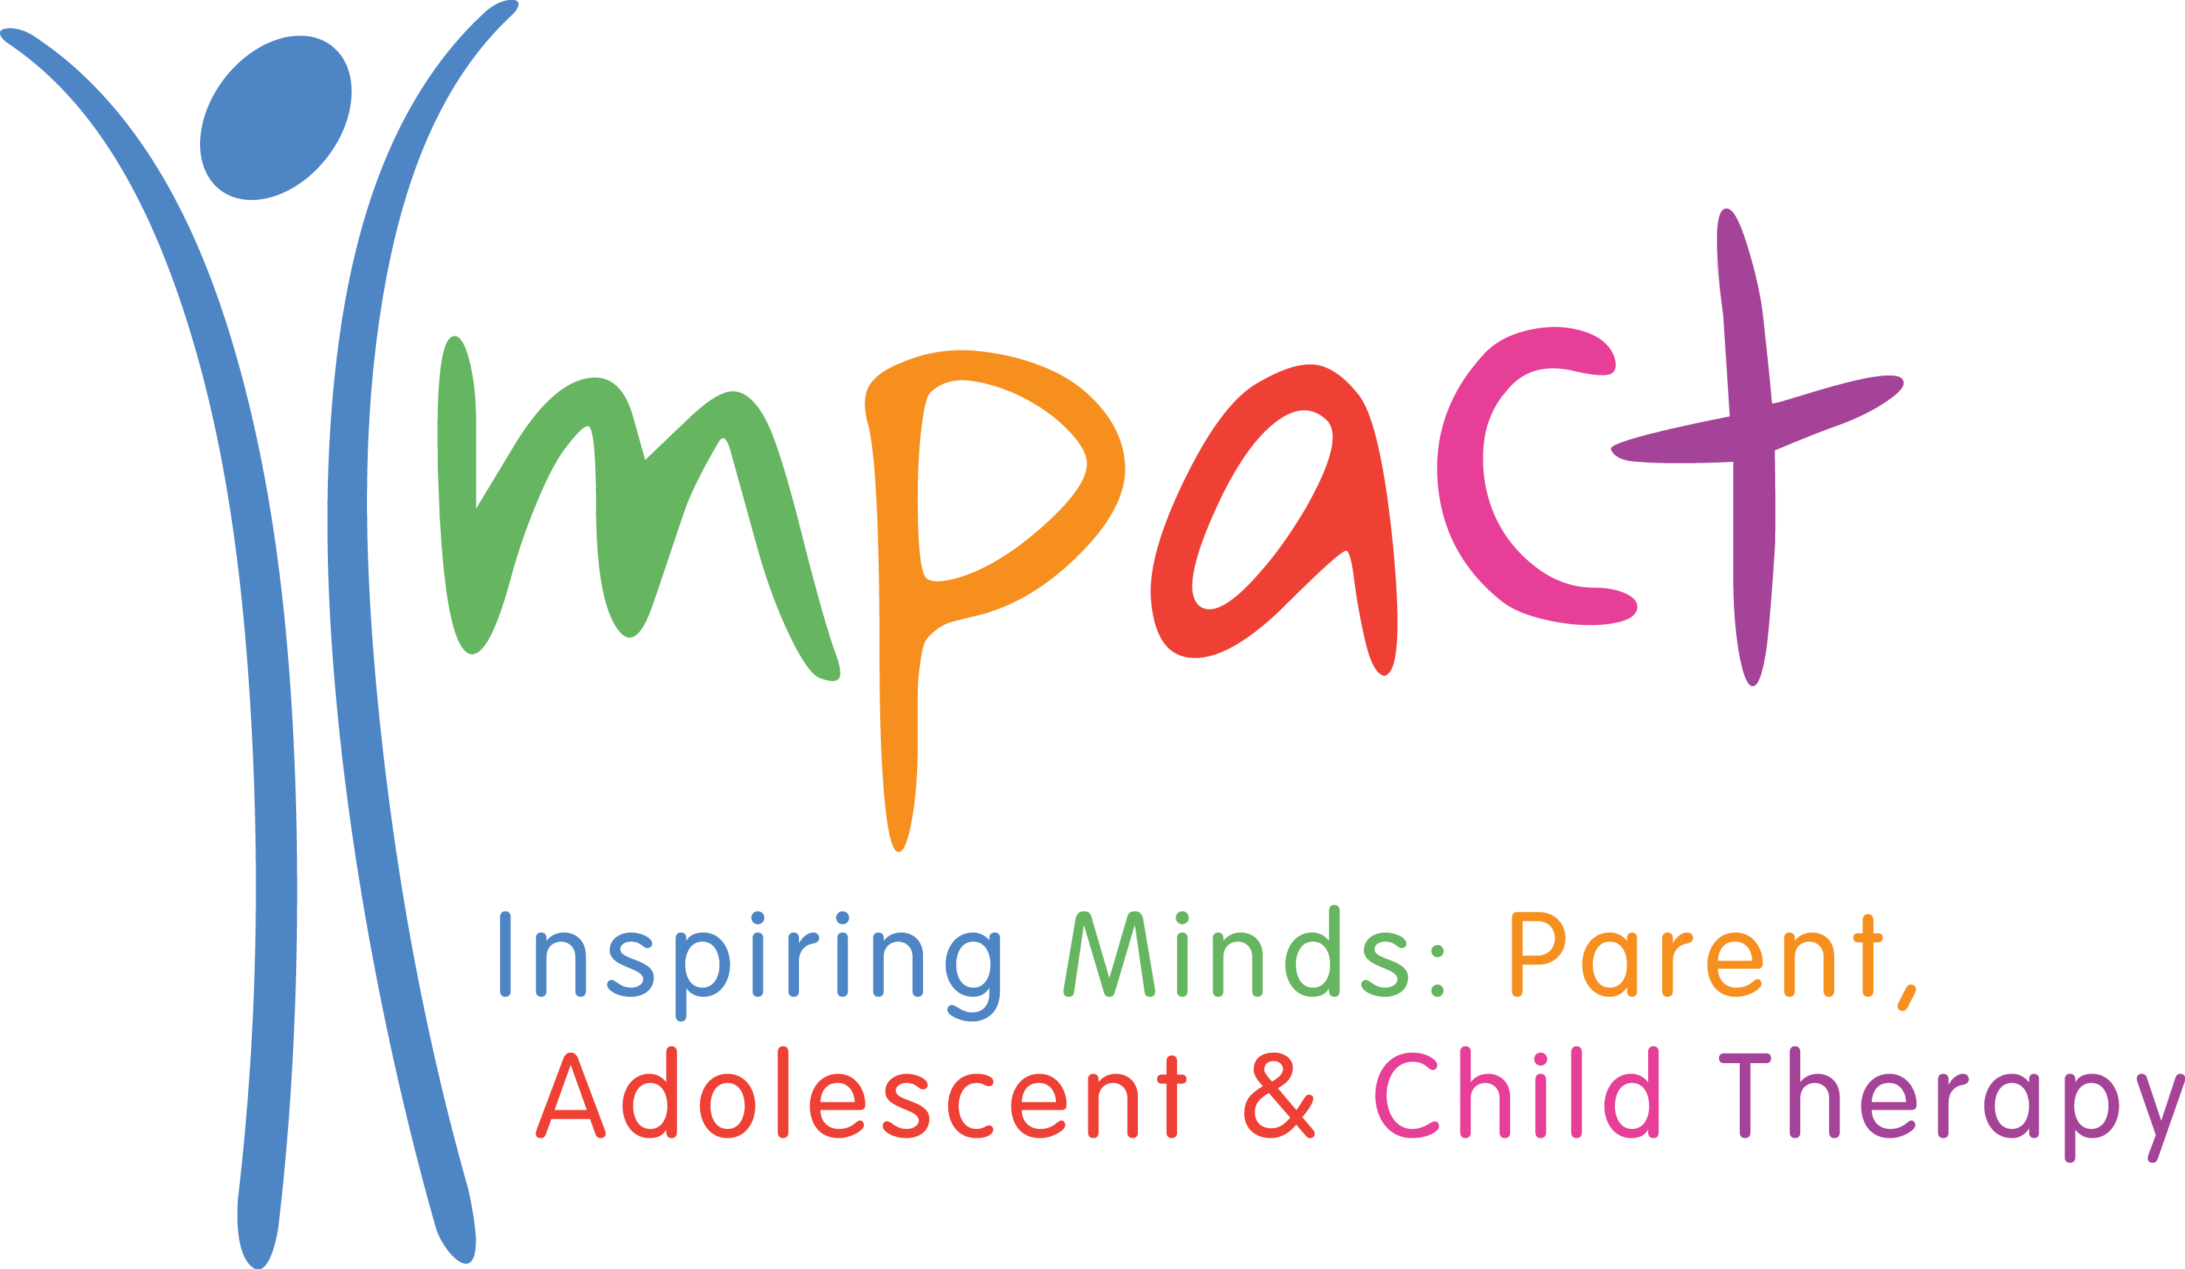

Parent Space
Information for Referrers

What is Parent Space ?

Parent Space is a unique project funded by the Pudsey Cluster that has been put in place to address parents’ mental and emotional health where it is demonstrated that this is having an impact on the child in achieving and maintaining the 5 outcomes identified in the Leeds Children and Young People’s Plan.

Purpose

The purpose of Parent Space is to support parents who are experiencing mental/emotional health problems. The parent, or a practitioner working with them, is worried that their mental or emotional health may be impacting on their parental capacities and so affecting their child’s emotional development.

Aim

The aim of Parent Space sessions is to offer parents some non-judgemental understanding of the difficulties and concerns they have in their relationships with their children. Listening to parents’ thoughts and feelings can help them to feel more able to reflect on their child’s experience and promote understanding of the ways in which children try to communicate their worried feelings. In this way, positive change in family relationships can be brought about. Parent Space works best by using a collaborative approach between:
- The Parent Space child psychotherapist with specialist skills in parent/child relationships and mental/emotional health difficulties
- The skills/knowledge of a support worker/practitioner who has an on-going relationship with the family. The support worker could be, but is not restricted to, Family Outreach Worker, Learning Mentor, SENCO etc.
What does Parent Space offer ?

It offers a tolerant, non-judgemental space with a qualified, NHS-trained, child & adolescent psychotherapist in which parents can explore issues that concern them and begin to make sense of their child’s behaviour and emotional functioning. Typically, up to seven 60 minute sessions are offered. In some cases, further sessions can be arranged. Sessions can be offered for parents alone or parents together with their child, or children, depending on the needs of the family

How to make a referral

Having obtained permission from parents, complete the Parent Space Service Request form (available on the Pudsey Cluster website www.pudseycluster.org). A consultation will then be arranged with the relevant Parent Space child psychotherapist to discuss the referral before a decision is made about seeing the family.

Feedback from parents

‘I think Parent Space is a brilliant therapy, I think all parents can get a lot from it.’

‘It was brilliant to be able to just talk to someone without being judged or patronised.’
‘This really helped me to keep things in perspective, work through my problems and see things a little differently so I could work on the relationship I had with my children.’

‘My experience at Parent Space has been nothing but positive.’

‘An excellent service to parents.’

‘I feel happier and can deal with things with a more open mind.’

‘After my first session I felt so uplifted and better from talking so much through. She really helped me make sense of my son in ways I had not thought about.’

‘A brilliant service that’s not known about enough.’

Feedback from referrers

‘Our mental health parents can be hard to understand sometimes. This is a place for me to park the complexities of these families in the right place.’

‘Families that I have referred have told me that they find this space useful and can relate to what their child is struggling with.’

‘I think Parent Space is a really useful service that complements what Family Outreach Workers are working to achieve.’

‘I like the way mental health can be approached in a positive manner, without parents/professionals being judged. Mental health is very complex and Family Outreach Workers can often struggle.’

‘This service is such a good service for parents and children and an invaluable service for school practitioners to refer parents to.’

