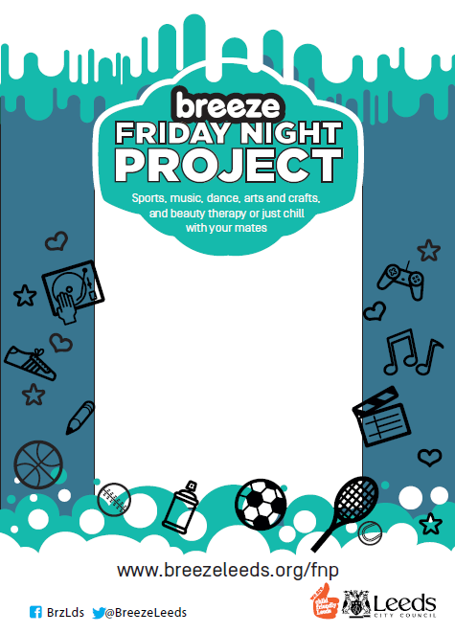

**@Pudsey Leisure Centre**

**Juniors (8-13 years) 6-7.30pm**

**Seniors (12-18 years) 7.30-9pm**

**£1.50 / £1.00 WITH A BREEZECARD**

**What’s coming up?**

**Weekly activities:** multi-sports, arts, wii games, table tennis and more!...

**Additional activities:**

21st April – Beauty therapy and Monster Puppets

28th April - 19th May – Mural Arts Project

26th May and 2nd June - Closed

9th June – Open - Activities TBC

16th June – Beauty therapy

23rd June - Open - Activities TBC

30th June - baton twirling, urban dance and international dance styles taster sessions

7th July- Open - Activities TBC

14th July- Open - Activities TBC

21st July to 1st Sept - CLOSED